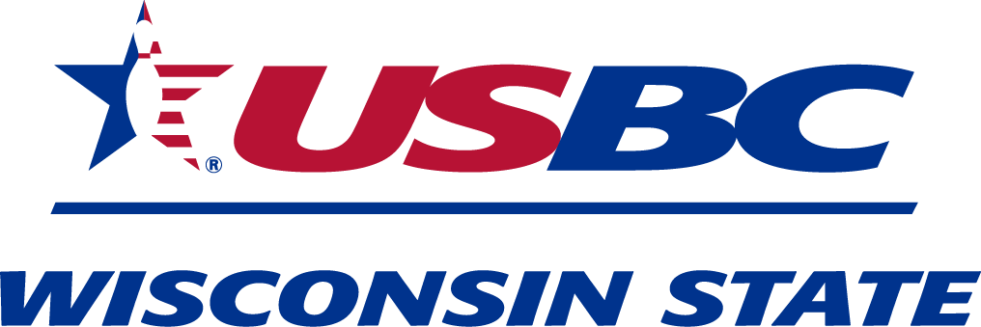

2021 Wisconsin State USBC

JAMBO-EXPO
  - June 26th – June 27th , 2021
Best Western Premier Waterfront Hotel & Convention Center
1 North Main Street
Oshkosh, WI 54901

Ladies and Gentlemen:

We would like to cordially invite you to the 2021 “Jambo-Expo”. This invitation is open to all Association Officers and Directors, as well as all Wisconsin State USBC bowlers in the hopes that this will be an event that everyone can find something they will enjoy.

SATURDAY June 26th, 2021
•9:00 AM – 10:00 AM - Youth State tournament pre-registration
•10:30 AM - 12:00 PM – Carlene Beyer, 2 -time Wisconsin State High School Singles Champion (2016 & 2017), 2019 NCAA National Championship Team. Hear about transition from junior league to High School bowling to Collegiate competition. Hear about recruiting and what to look for in a collegiate program.
•12:00 PM to 1:00 PM (YOYO) - Luncheon
•1:00 PM to 2:30 PM - Collegiate Coach speaker – Andy Diercks, Mt Mercy University – Team USA Asst. Coach
•4:00pm to 5:30pm - Youth Scholarship Awards Dinner / Banquet ($15.00)
•7:00 PM to 9:00 PM - Adult/Youth Baker Doubles ($30.00 per Team)
Check in will be 6:15 PM - 6:45 PM
3 divisions (U12, U15, U18), 4 games total (based on August 1, 2020)
Rev’s Bowl, Bar & Grill, 275 N Washburn St, Oshkosh, WI 54904
All prizes will be deposited in the SMART program account for winners

SUNDAY June 27th, 2021

•500/600 – Junior Gold Qualifier Tournament (2 squads)
9:30 AM (Check in is 8:15 AM-9:15 AM) 12:30 PM (Check in is 11:15 PM – 12:15 PM)

Adult/Youth Baker and 500/600 – Junior Gold Qualifier will take place at:
Rev’s Bowl, Bar & Grill
275 N Washburn St.
Oshkosh, WI 54904

